DCR Process Manual

1) Create an Excel file to Import as shown below for PAN India.
There should not be any spelling mistake in centre name else application will not accept that case. Verification types Cheque Verification (CV) & Document Verification (DCV).We can import PAN INDIA details at one time.

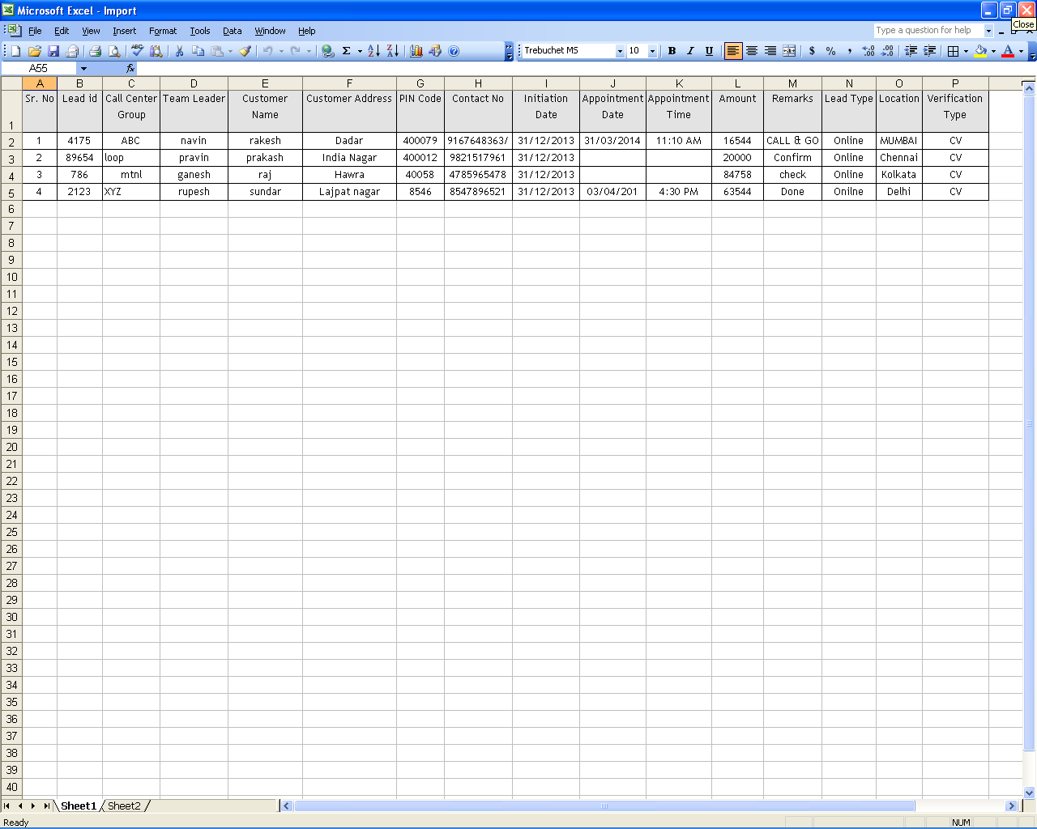
2) Login -> DCR -> DCR -> Select required Client

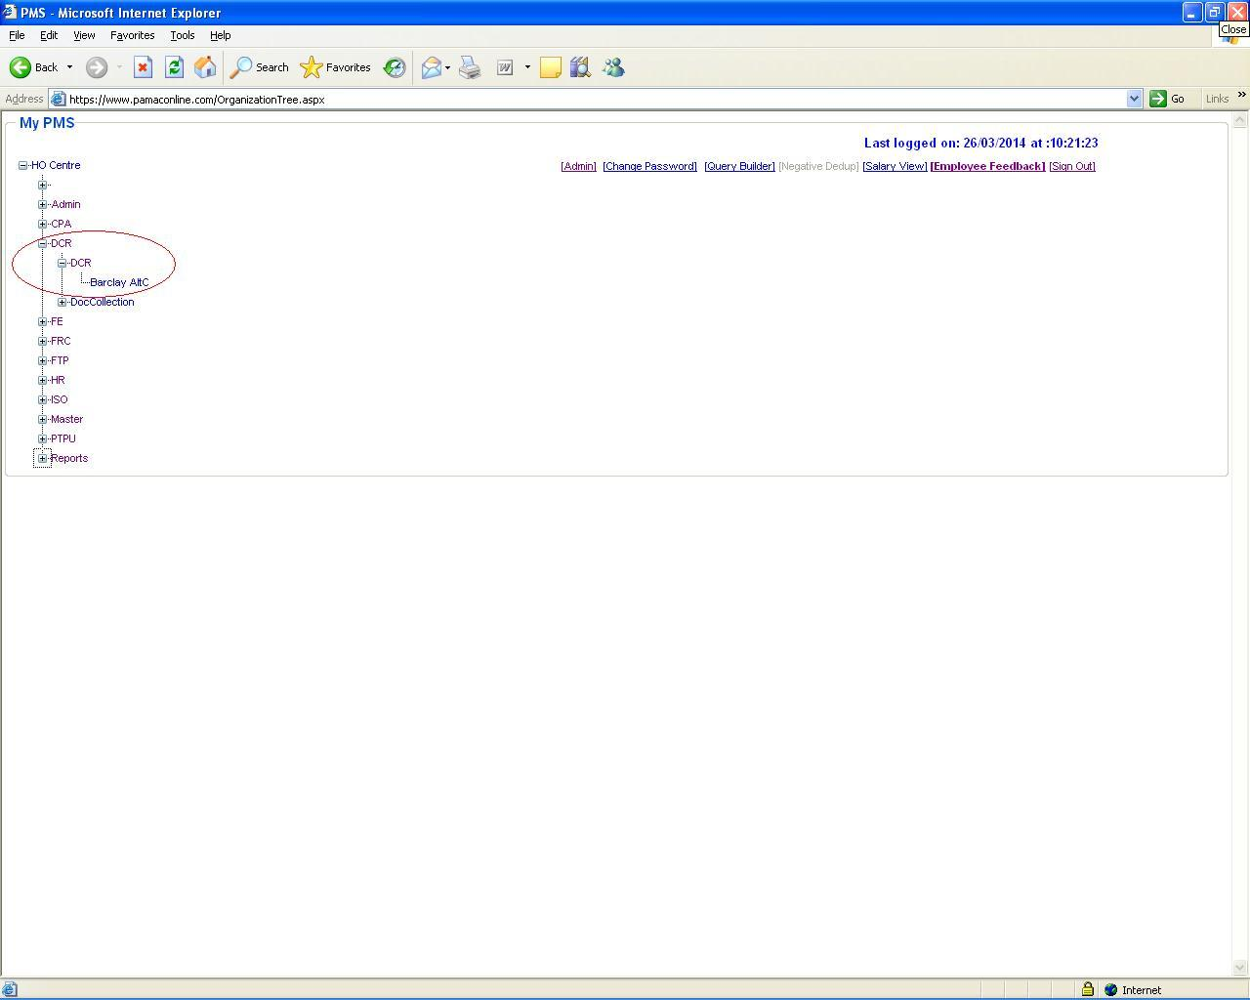
3) Data Files -> Import Client File

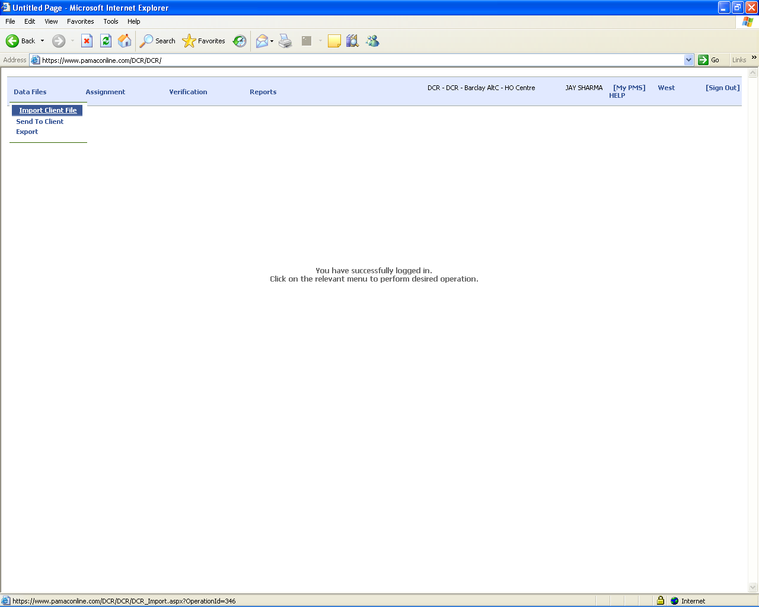
4) Select file to be Import & fill all the details and click on Import button.
Case Receive Date & Time are mandatory fields.

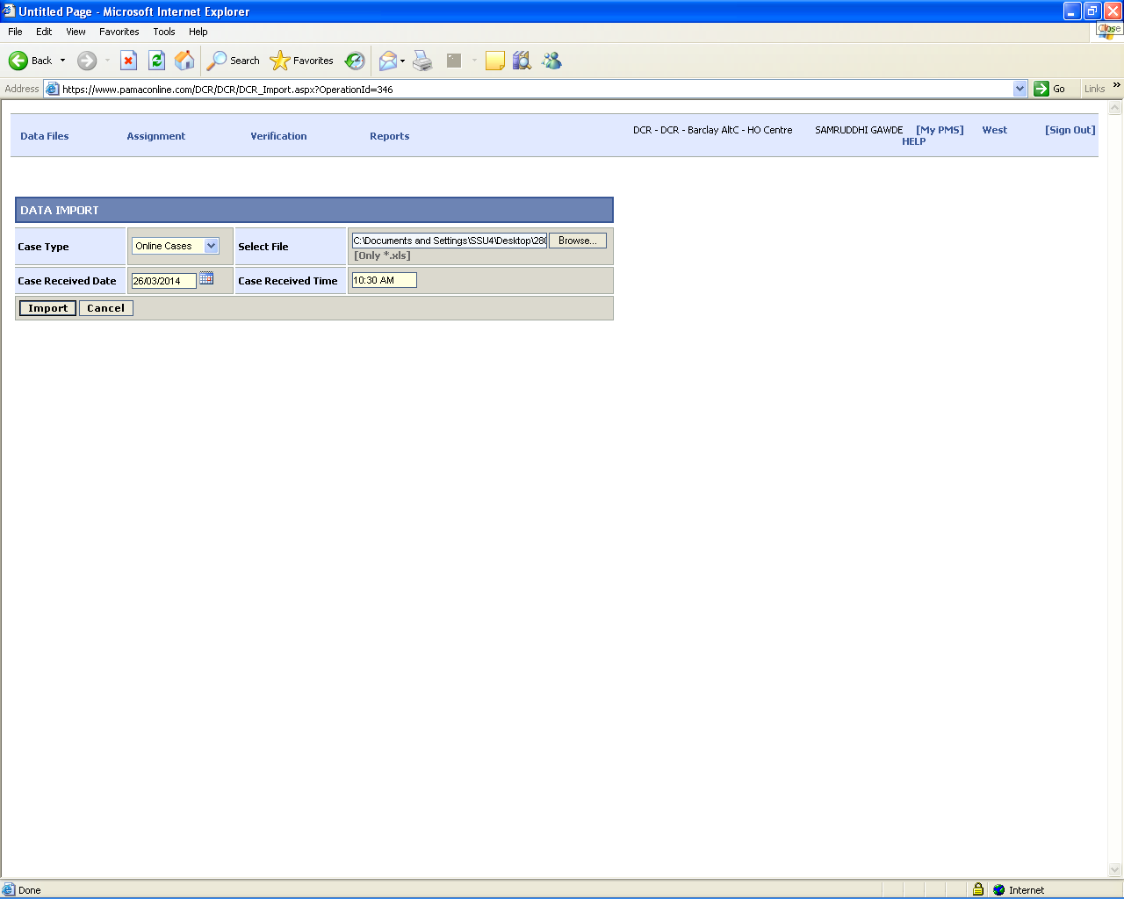
5) After importing the file.” Record Saved Successfully” message will display with count.

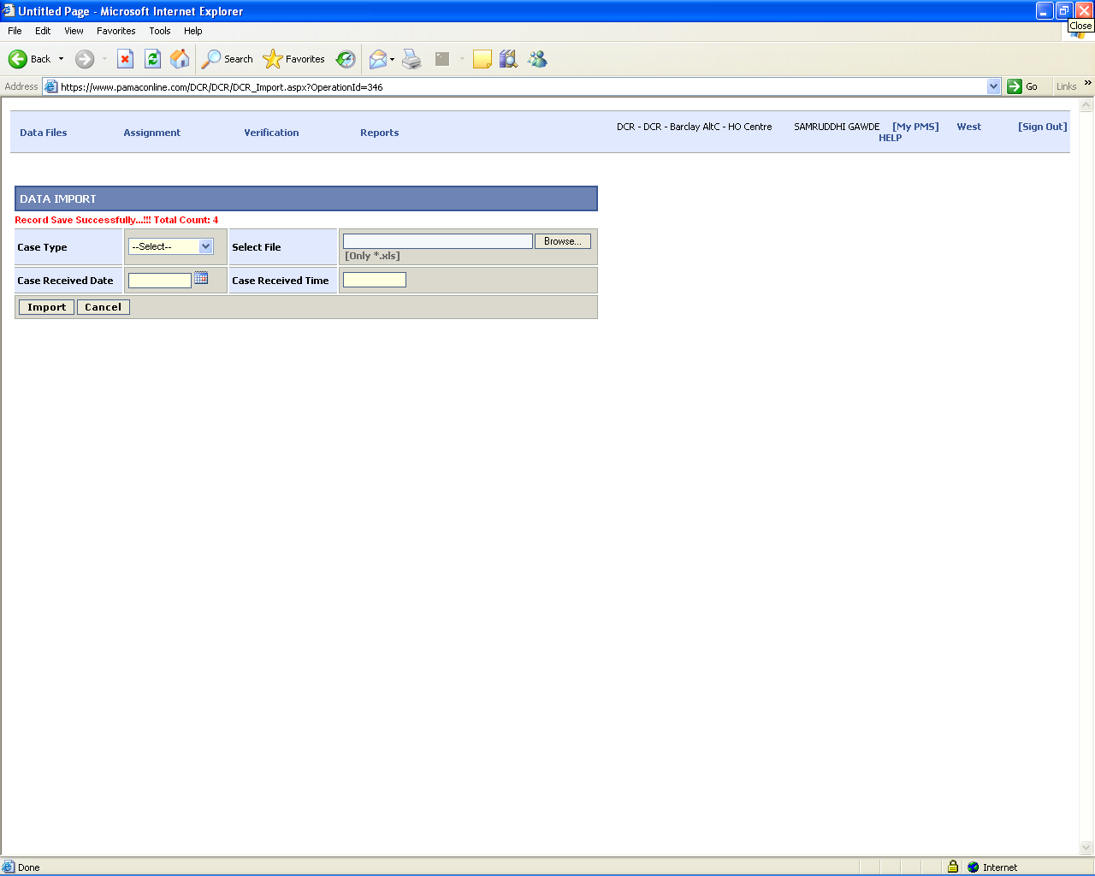
6) Select “Assignment -> FE/Tele Assignment” for assigning case(s).

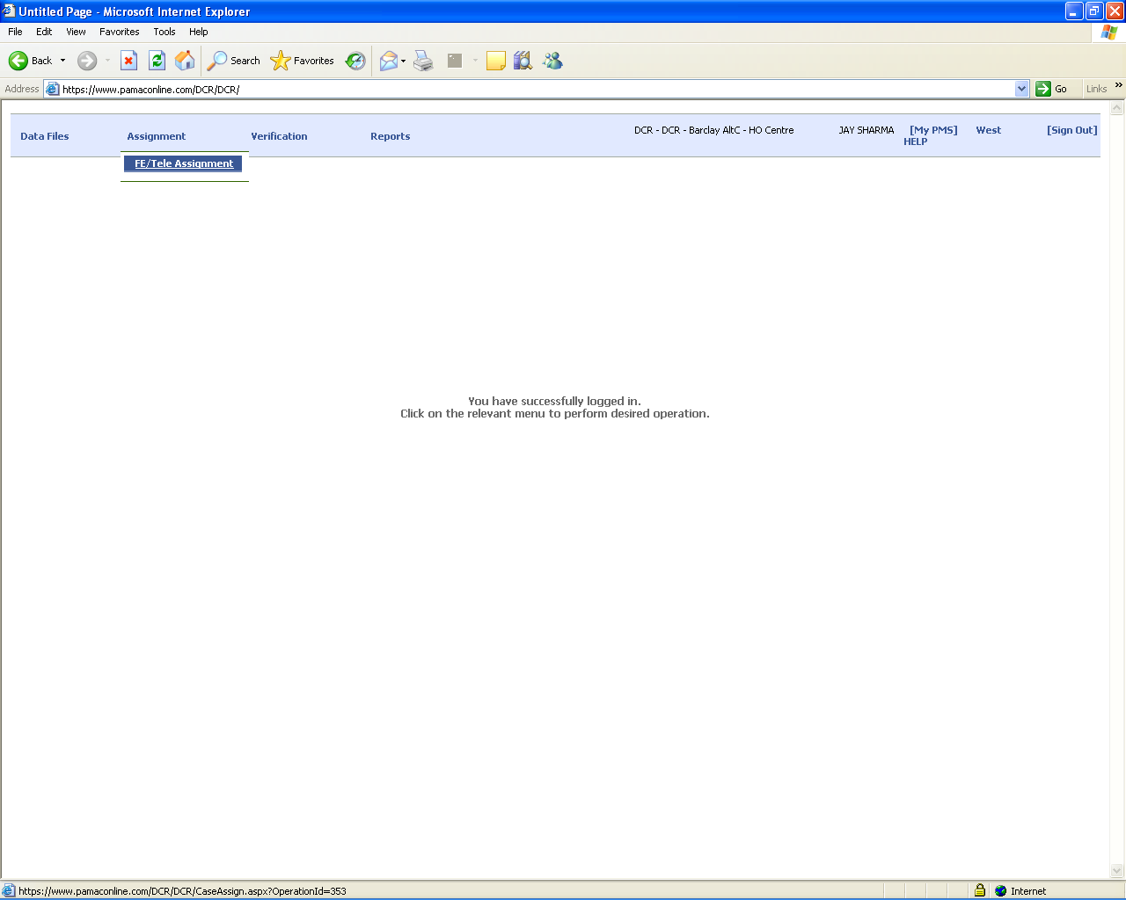

7) If “Appointment Date & Appointment Time” field is NOT blank then select “Field Executive” from “Case Assign To” and select other options to search the record and assign the case(s) to particular Field Executive.

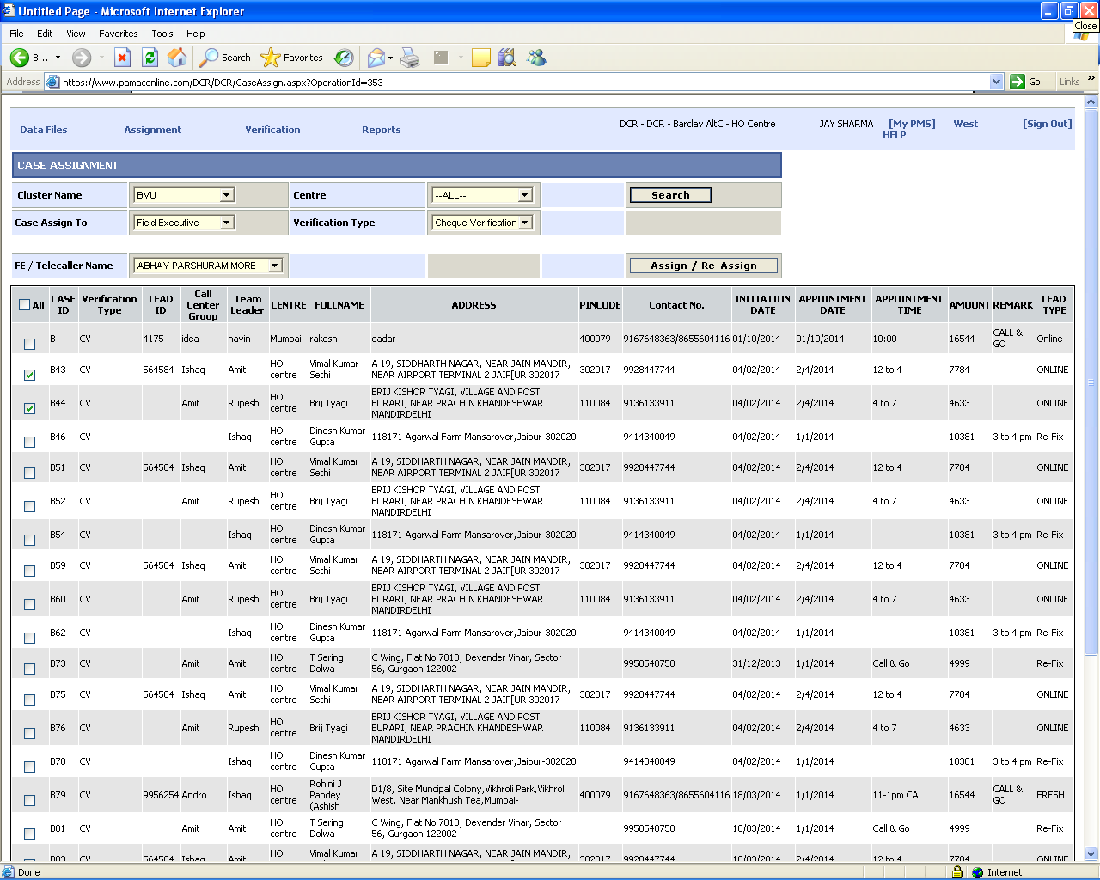
8) After assigning case(s) to Field Executive.

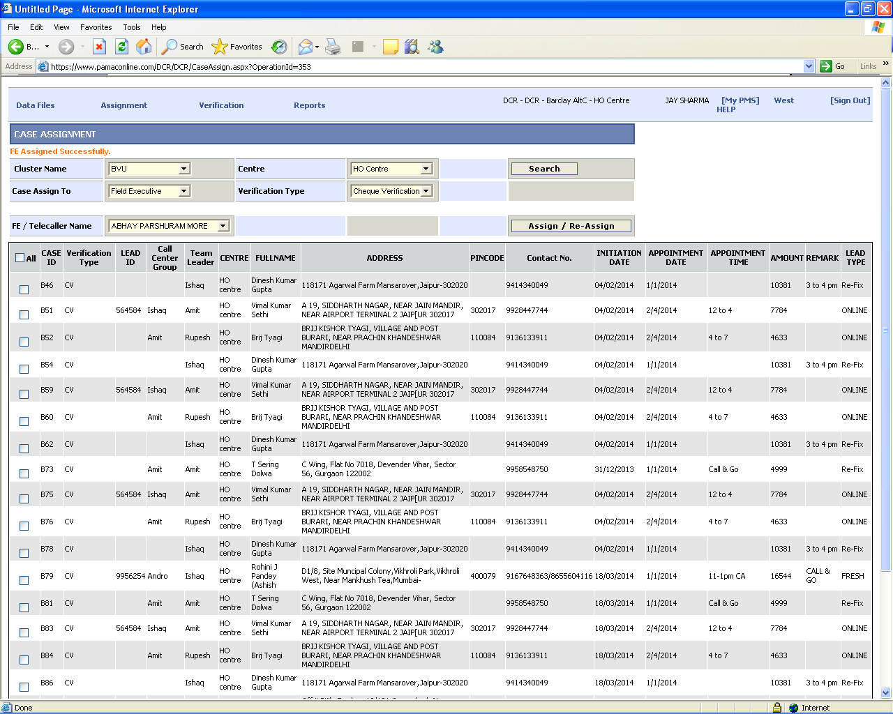
9) If “Appointment Date & Appointment Time” field is blank then select “Tele Caller” from “Case Assign To” and select other options to search the record and assign the case(s) to particular Tele Caller.

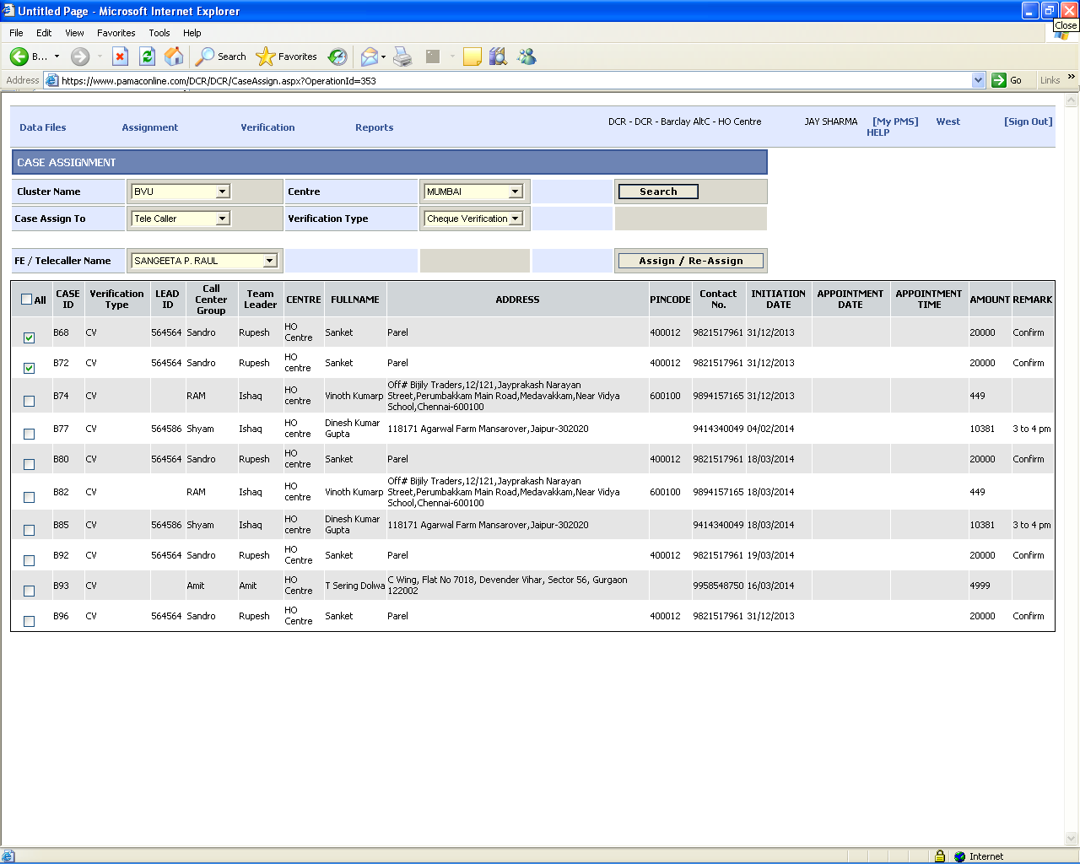
10) After assigning case(s) to Tele Caller.

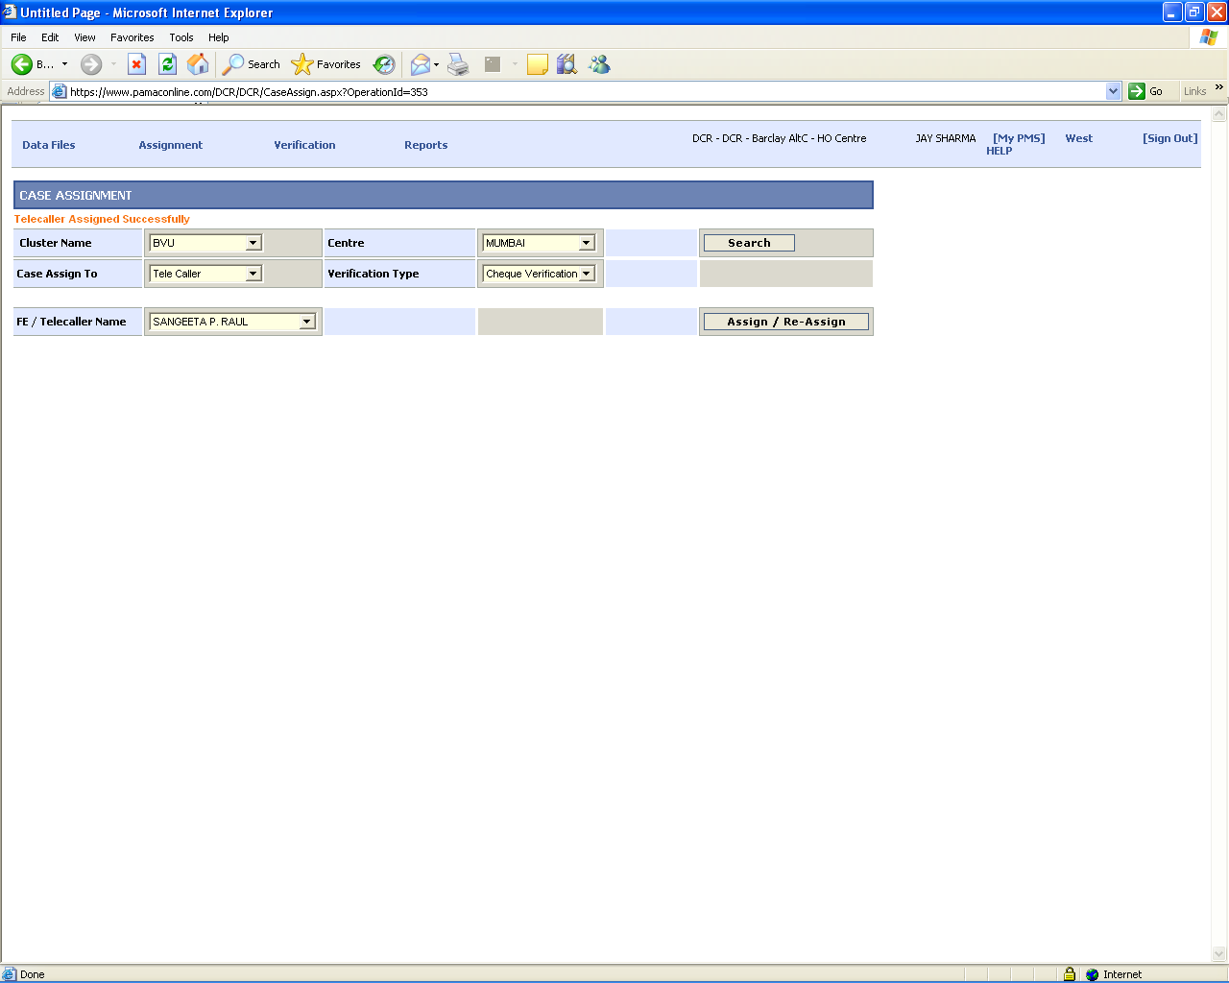
11) Tele Caller Login -> DCR -> DCR -> Select Particular Client -> Tele Calling.

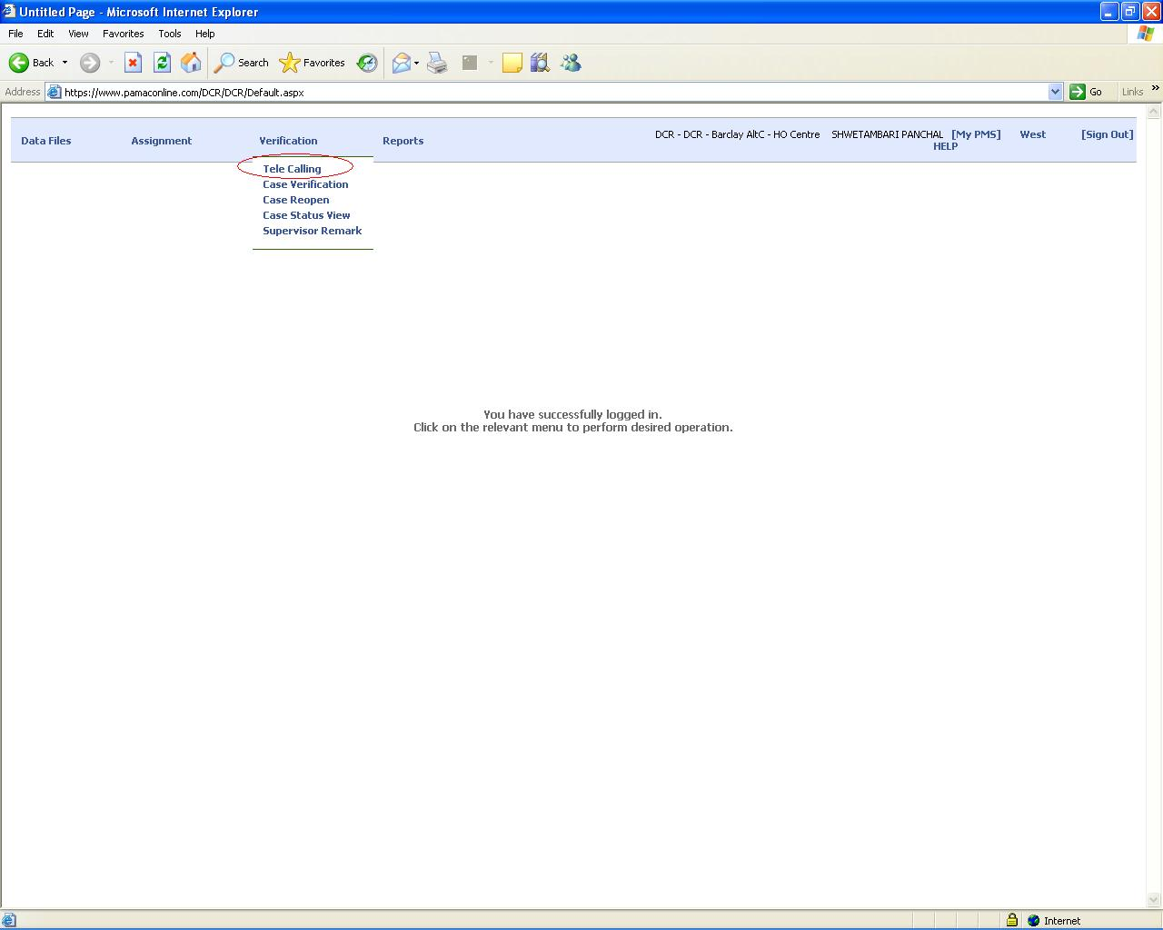
12) Tele Caller will get the number of cases assigned to him/her only(here tele caller will received cases for PAN INDA locations ). By clicking Edit option from Gridview, Tele Caller will fill all the details with particular STATUS as per telephonic conversation.

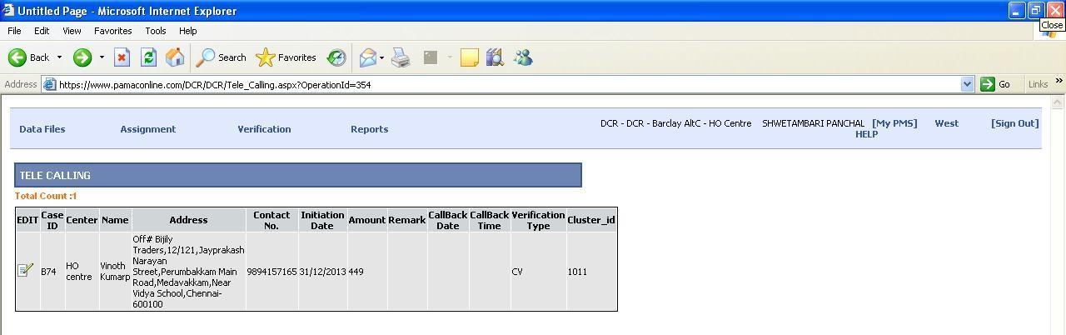

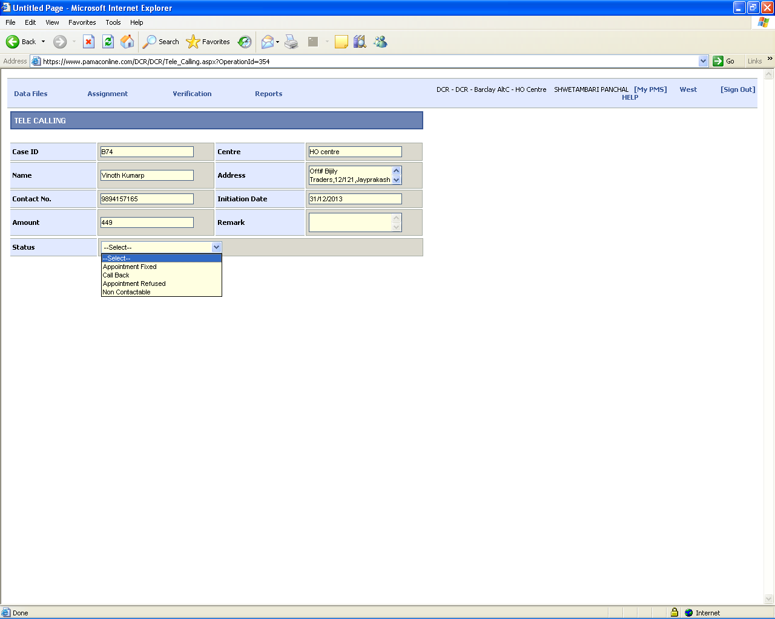

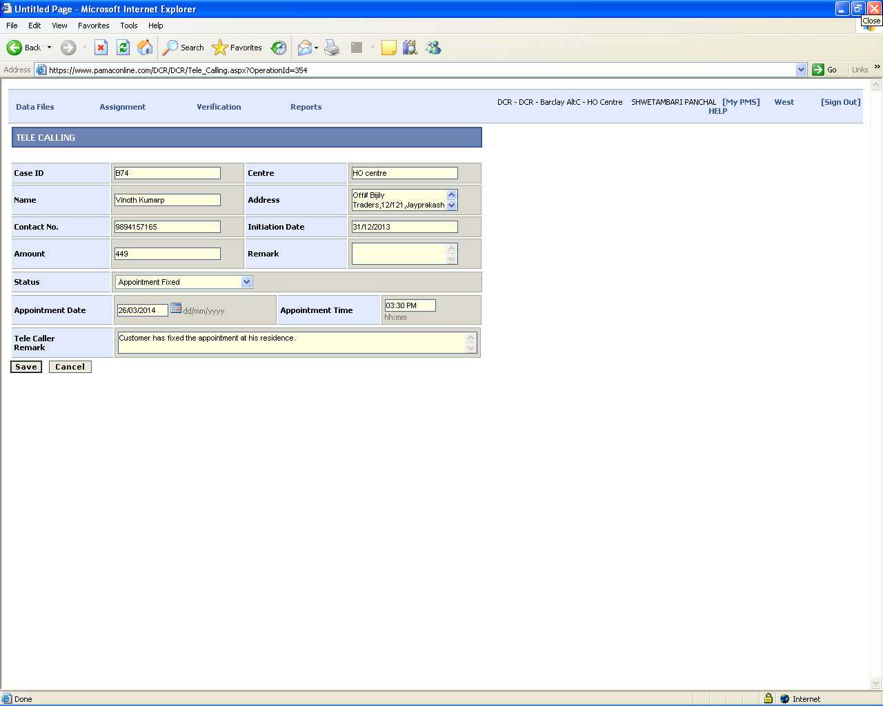
13) After “Tele Calling” the particular case will reflect in Field Executive (FE) tray and then follow the process as per Point # 6, 7, 8.

14) Select “Verification -> Case Verification” & Search the record by CASE-ID and Verification Type.

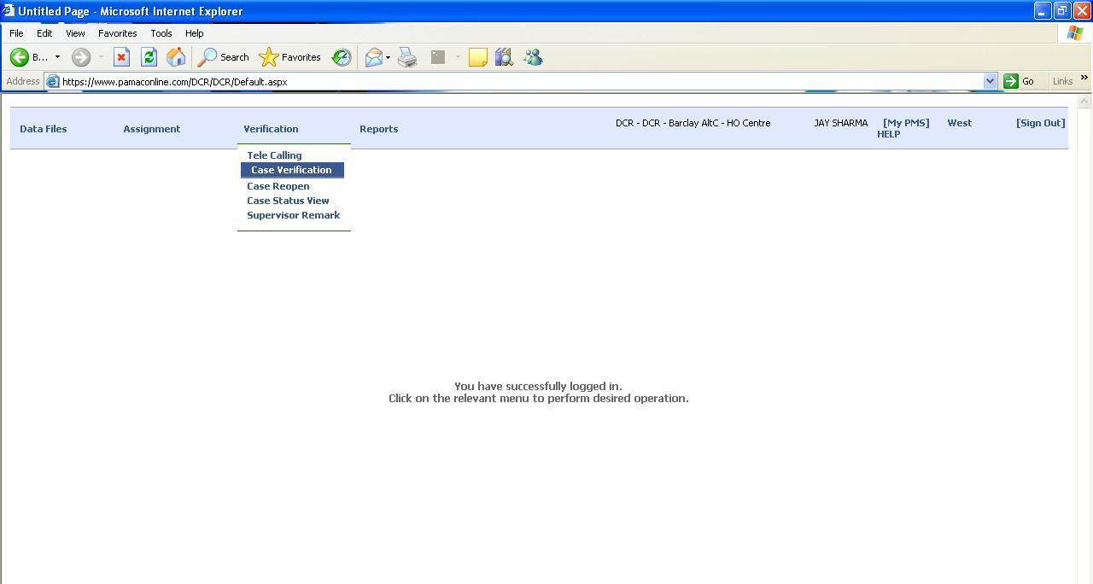

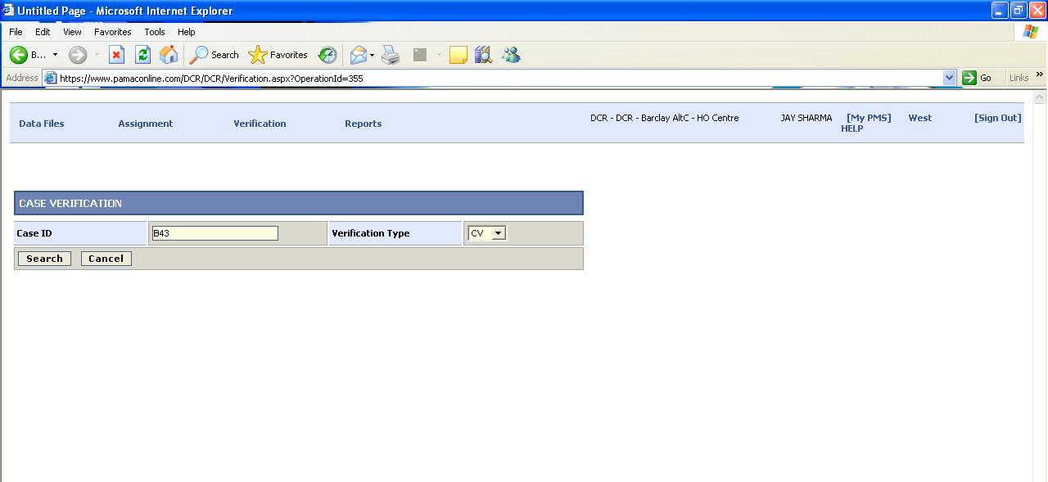

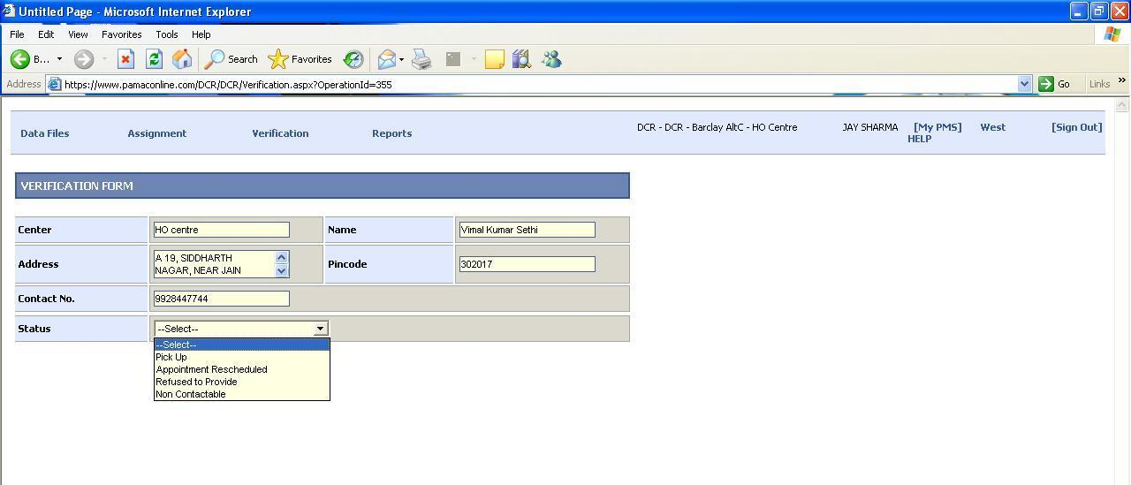

Fill all the details by selecting particular STATUS and Save the record.

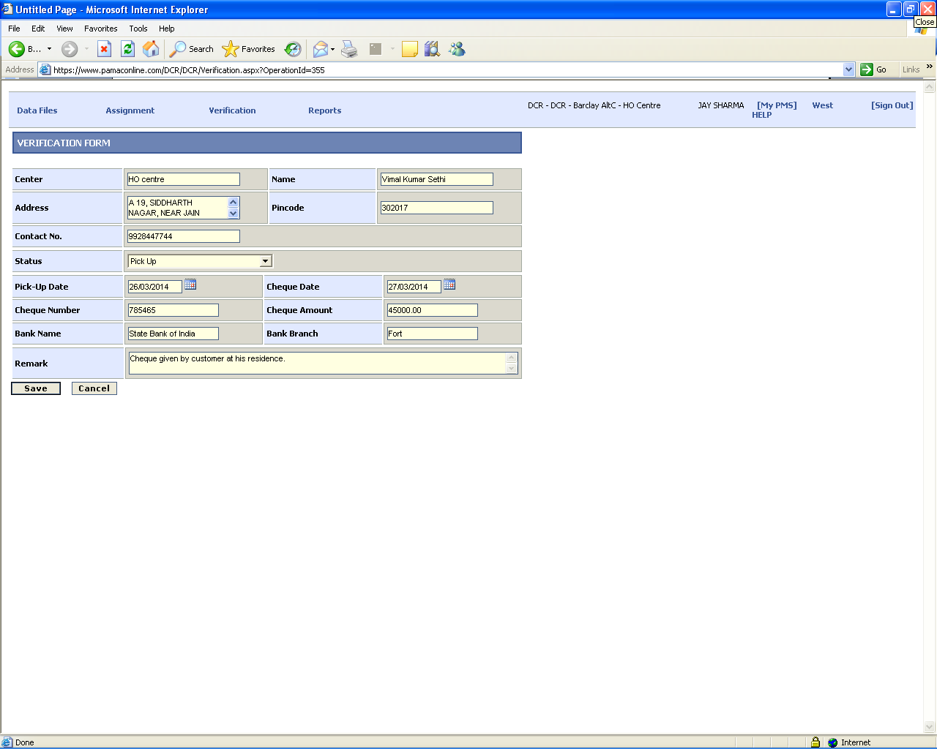
15) After “Case Verification”, Supervisor will give his/her remark to the particular case(s).
Select “Verification -> Supervisor Remark” and Search the record by CASE-ID.

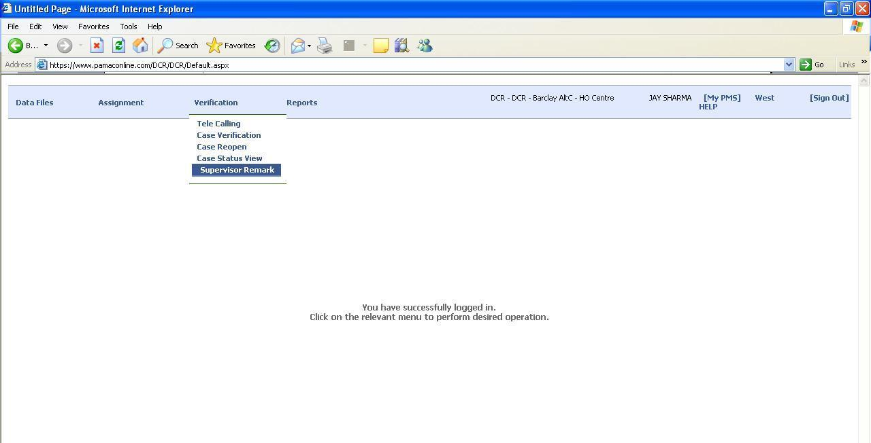

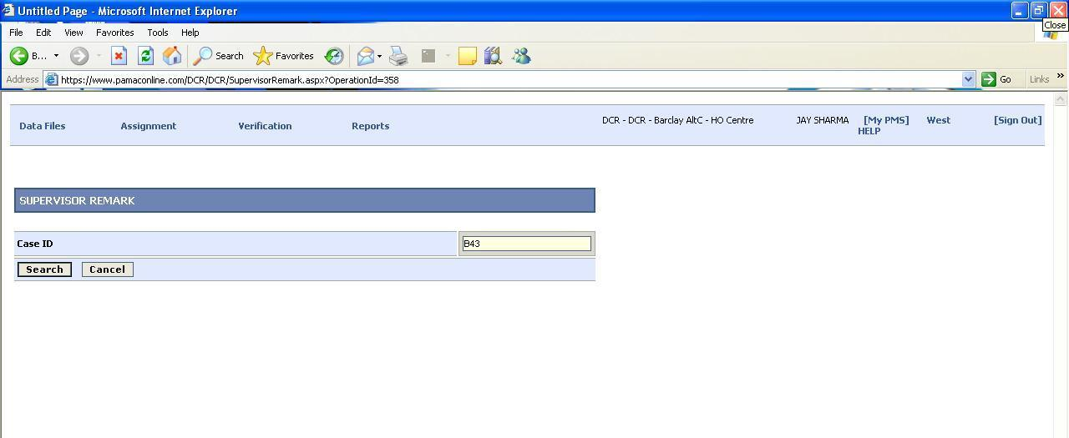
16) Supervisor will fill all the details against the particular CASE-ID by selecting STATUS and SAVE the record.

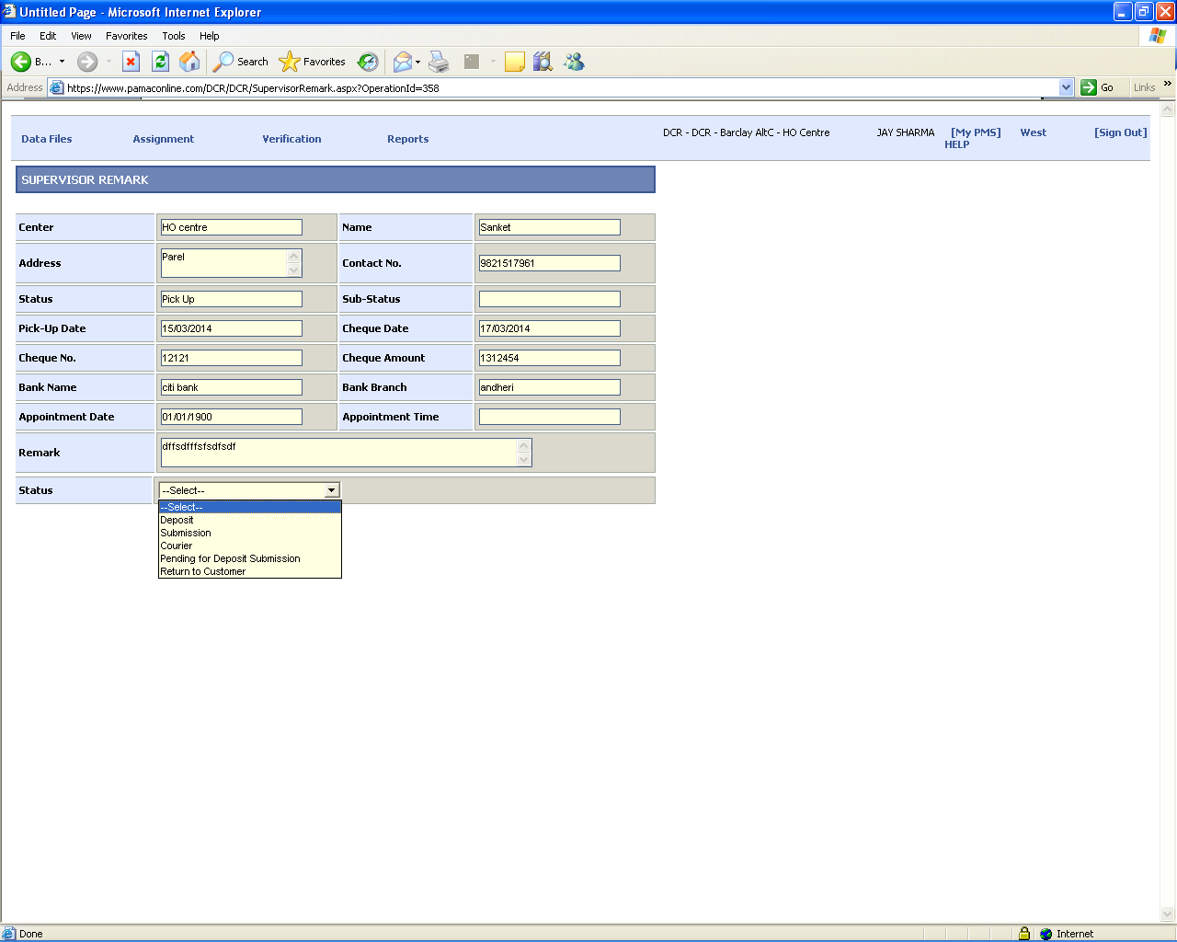

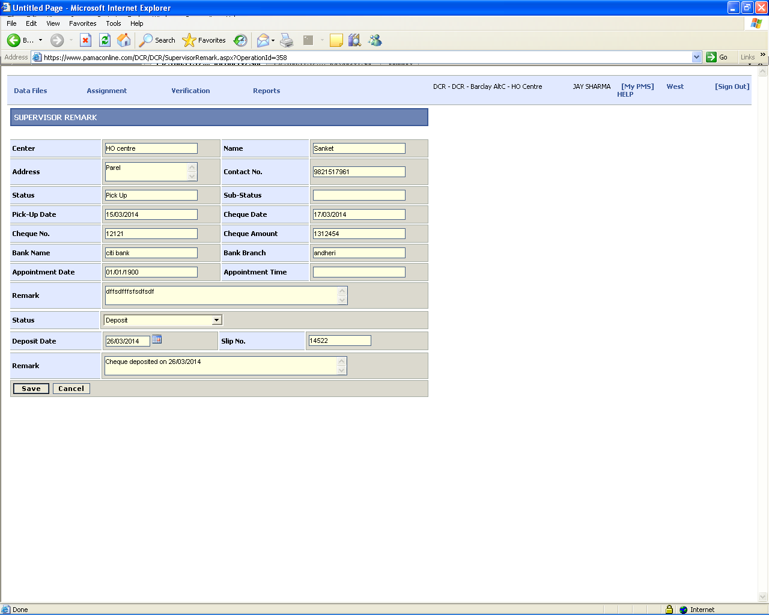
17) After Supervisor Remark, Send the case to the client by selecting
“Data Files -> Send To Client”.

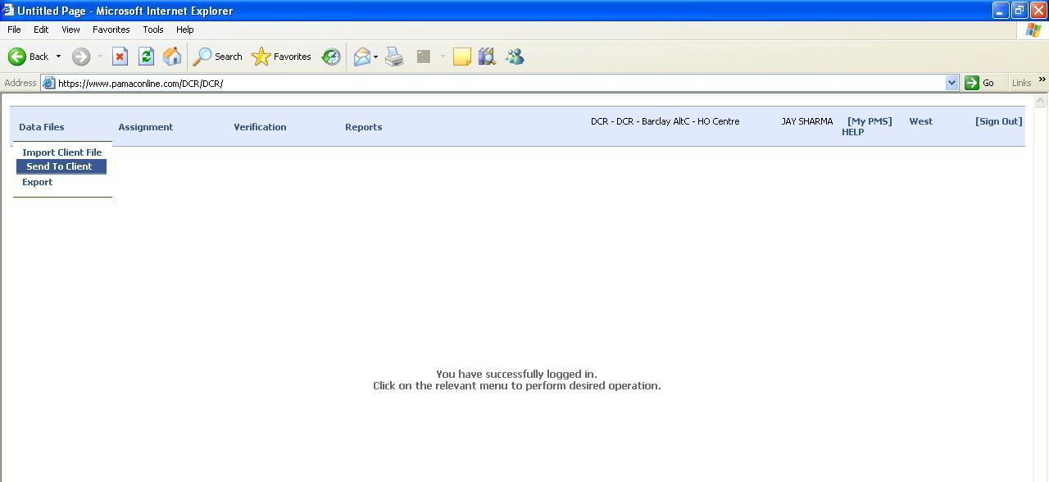

Search the Case with all the details.
Select Case -> Click “TatCalculation” button -> Tick “Within TAT” (if any) -> Click “SendToClient” button.

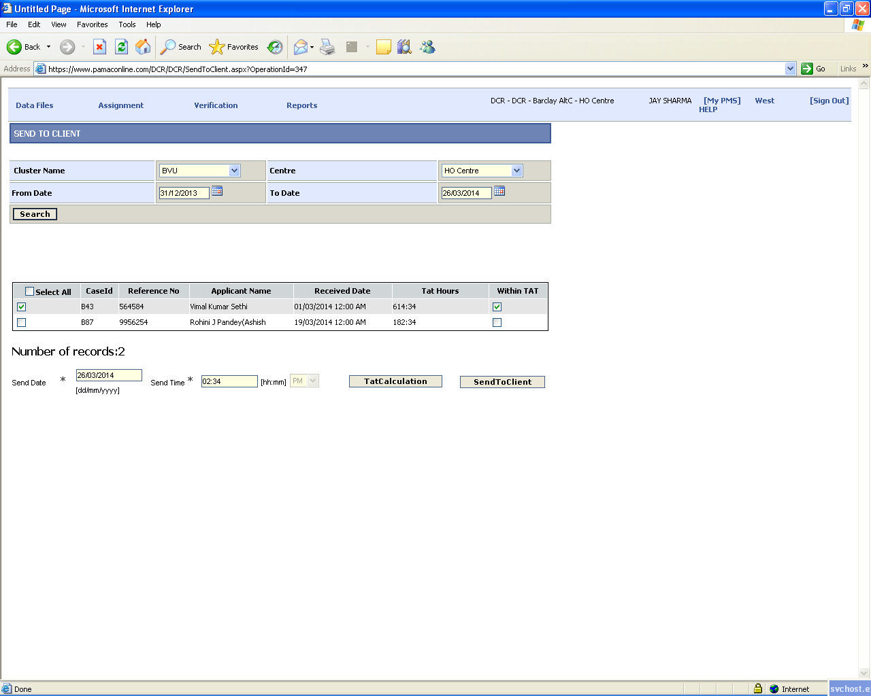

After Send to the client case will move out from all trays.
